# 1 Introduction

In this activity, we will use the Power Query feature of Microsoft Excel to download some data from the IMDB web source and display these data in an Excel table.

We will also see how to edit, refresh, and duplicate Queries.

## 1.1 Prerequisites

Familiarity with Microsoft Excel is helpful, but not essential.

# 2 Create a Query

In this step, we will create a Query that imports IMDB data from the web, parses and tidies the file contents, and displays the output in a table on the worksheet.

## 2.1 Get the IMDB URL

Follow the link to <https://www.imdb.com/>

Click on the Menu hamburger:



Select Top 250 Movies



Copy the URL using Ctrl-C and paste it if necessary, e.g. into Notepad using CtrlV



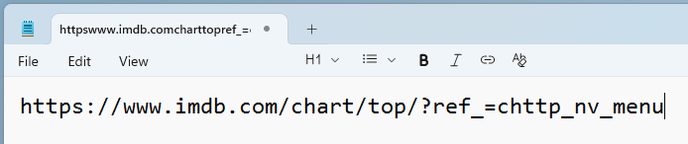

## 2.2 Create a From Web Query

Open a new Excel workbook. Save it as movies.xlsx in a folder of your choice.

Navigate to Ribbon > Data tab > Get & Transform Data group > From Web.

Paste the saved URL into the URL field.

Leave the Basic radio button selected. Click OK.

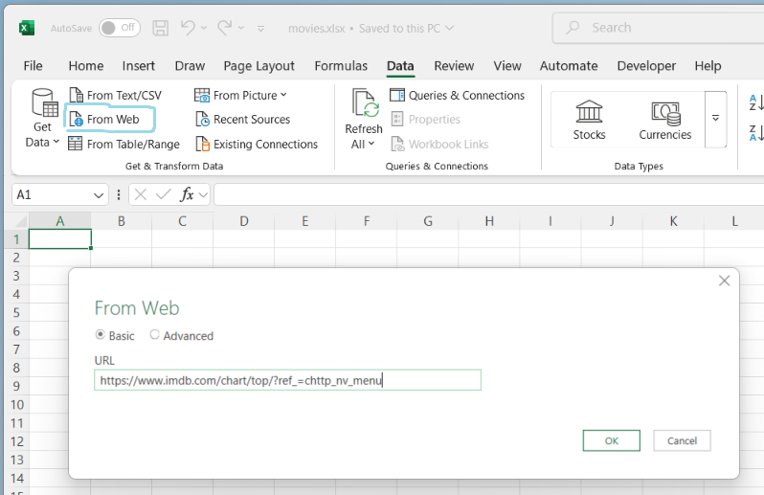

The Navigator dialog appears.

You may get a choice of suggested tables. If so, choose the one that resembles the one below and select Load.

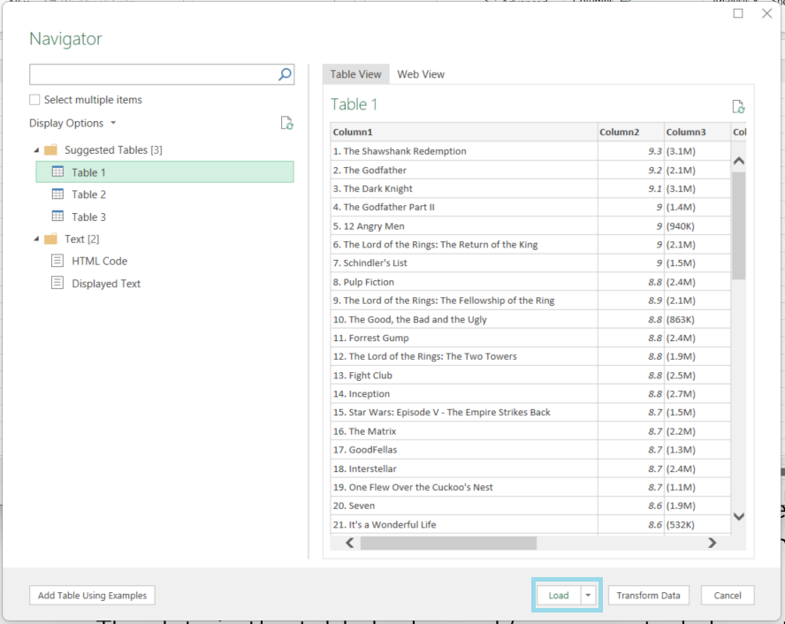

(Note: if we were to instead click **Transform Data**, this would bring up the Power Query Editor window. We will explore that feature later.)

The data source is loaded as a table on a new worksheet. We also see that a panel called Queries & Connections has appeared. This panel displays the name of the Query associated with the data in the table. Later, we will see how we can edit and refresh this Query.

The default name of our Query is generic and meaningless. To change it, right-click the name of the Query in the Queries & Connections panel and click Rename. Give the Query a short name such as ‘qryFilms’. The ‘qry’ prefix helps remind us that this is a Query.

If Rename is not available, click on the … and select Properties. Then, in the Query Properties dialog box, make the change in the Query name field and click OK.

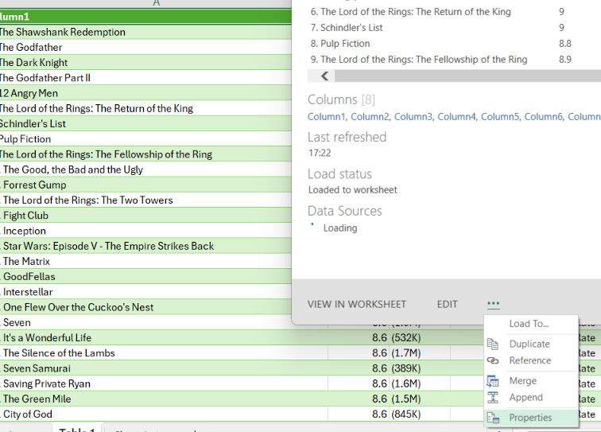

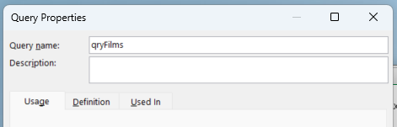

If we navigate to Ribbon > Table Design tab, we can see that the table adopts the same name as its associated Query.

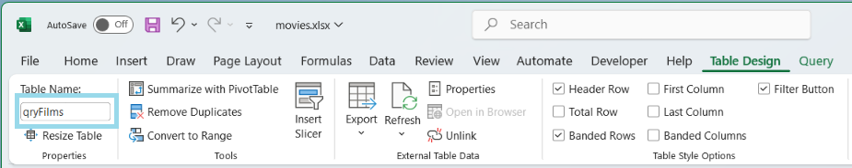

Let’s also rename the worksheet to qryFilms. Right click on the Table 1 tag and select Rename.

